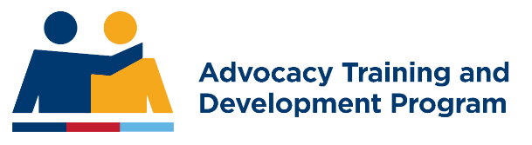
Your ESO or VSC LOGO here

HELP US SUPPORT THE VETERAN COMMUNITY BY VOLUNTEERING AS AN ADVOCATE OR ADVOCATE SUPPORT OFFICER

[Name of Ex-Service Organisation /Veteran Support Centre]
Volunteer Advocacy & Advocate Support

OVERVIEW
Thank you for your interest in volunteering as an advocate or advocate support officer.
Of all the ways we help your ex-ADF mates, these ‘hands on’ advocacy roles offer a unique opportunity to change lives. If you decide to volunteer, you will join a group of well-trained, highly skilled and committed people who share your passion for assisting veterans and their families in very important ways. You will be helping those who have served, their dependents and those who support them in their day to day lives. Their wellbeing will be both your objective and reward.
There are two advocacy streams known as advocates and advocate support officers. They both work with veterans and their dependents, and war widow(er)s. Our advocates undergo formal training and are accredited upon its successful completion. They connect veterans with wellbeing services or prepare compensation claims and appeals. Our support officers may be trained in a variety of ways but are not accredited. They normally work in conjunction with advocates to triage caseloads and provide support to both advocates and their clients. This support may take many forms and we can discuss how our advocacy support arrangements work when you decide you would like more information from us about specific opportunities we can offer you to help your mates.

Purpose of the brochure
This Information Pack outlines broadly what our volunteer advocates and advocate support officers do to assist our members and clients. You will find out about:
- The benefits of volunteering as an advocate or advocate support officer,
- More about our advocates and advocate support officers’ roles,
- What commitments our volunteers are making,
- The training and support we and the Advocacy Training and Development Program (ATDP) provide, and
- What insurance cover is provided to advocates by the Veterans’ Indemnity and Training Association (VITA)


WHAT ARE THE BENEFITS OF BEING A VOLUNTEER?
Around one in three of our veterans are not travelling well as a result of their ADF service or transition into civilian life. Volunteering in an advocacy role is a great way to help them. You will provide structured assistance. Your support will help them build the resilience they need to cope with life after service.
Your role will involve helping veterans and their dependents whose lives have become out of balance. Your support will focus on the key elements of resilience – good health, safe housing, social support, education and skills, employment, justice and income.
Volunteering Australia, the national peak body for volunteering, has identified many benefits of volunteering. A recent survey emphasised two key factors that motivate volunteers. These are:
“The sense of purpose it gives me.”
“The difference I make to the community.”
Working as a volunteer advocate support officer, you will assist mates and their families get on with their lives by developing a stronger connection with their community and support networks, which can be intensely rewarding. Further, you will have the satisfaction of knowing that you have contributed to this process in a fundamental way. In these roles you will meet new people and be exposed to a range of different experiences. You will consolidate existing skills and develop new ones and in doing so you will learn a lot about yourself and others in the veteran and ex-service community.
We feel sure that you will find no better way to honour your mates’ service (and their dependents’) through steadfast support for them by volunteering in an advocacy role.
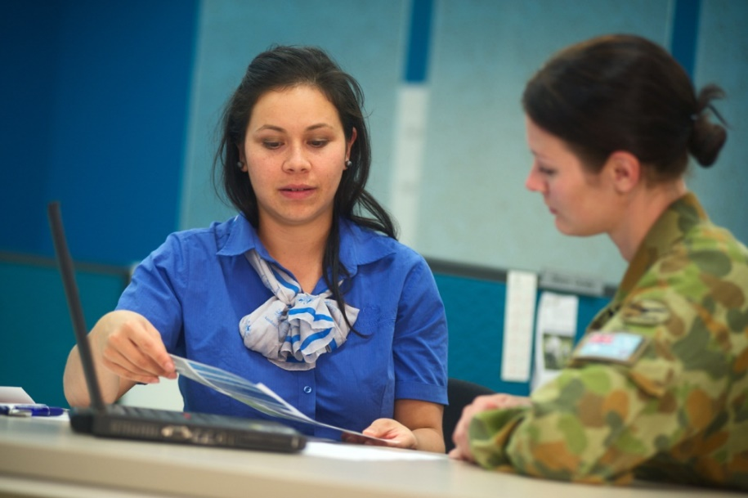

WHO CAN VOLUNTEER?

Our volunteers come from a wide range of backgrounds. These include people from all walks of life within and outside the veteran community. They can be retirees, younger veterans, partners of veterans, and anyone with an interest in veteran’s wellbeing and helping others.
If you are passionate about working for causes you believe in and have the time, energy and enthusiasm you are the type of person we are looking for to volunteer as a veterans’ advocate or advocacy support officer.

WHAT ROLES CAN I PERFORM AS AN ADVOCACY VOLUNTEER?
Our volunteer advocates and advocate support officers assist all members of the
ex-service community including veterans, their dependants and war/defence widow(er)s. The support our volunteers provide to our members varies between roles. There are four different volunteering roles which may interest you. However, please contact us and we will discuss with you the opportunities that are currently available. They are:

Wellbeing Support Officer (WSO)
These volunteers support veterans and their families by:
- Providing companionship by visiting clients in their home, hospital or aged-care facility,
- Driving, shopping and supporting domestic arrangements,
- Facilitating contact between Wellbeing Advocates and clients,
- Supporting Wellbeing Advocates in specific aspects of their role.
*WSOs are not accredited. They do not give advice or engage service providers.

Compensation Support Officer (CSO)
These volunteers assist Compensation Advocates by:
- Helping prepare for interviews,
- Conducting preliminary interviews,
- Researching and managing documentation related to claims and appeals.
*CSOs are not accredited. They do not give advice or lodge claims or appeals.

Wellbeing Advocate
Wellbeing Advocates provide information and advice to facilitate access to:
- Health, housing and other community services and benefits,
- The wide array of Federal, State, Local government services, including those available from DVA.
*These roles are accredited. They give advice and link clients with service providers.

Compensation Advocate
Compensation Advocates provide rehabilitation and compensation advice, with two broad levels of support:
- Assist with the preparation and lodgment of primary claims and applications,
- Prepare cases for Review (Reconsideration, Alternate Dispute Resolution (ADR) process and appeals to the Veterans’ Review Board or Administrative Appeals Tribunal) and represent veterans at the VRB and AAT.
*These roles are accredited. They give advice and/or lodge claims or appeals.

CAN I CHANGE VOLUNTEER ROLES?
You are not locked into one volunteer advocacy or advocacy support role. You can decide to change or add roles at any time as opportunities present themselves. We see this as important to your personal growth in terms of providing new challenges should you be looking for them. It also broadens your skills and knowledge, strengthens our advocacy team, and thereby enhances the quality of the support we can provide to both members and clients.


WHAT TRAINING AND SUPPORT WILL YOU RECEIVE?
If you decide to volunteer, please call in to see us. Our advocacy team will be very pleased to meet you. You do not need to decide which role you would like to volunteer for before you meet with us. We will talk to you about the roles and if you are interested give you exposure in various advocacy/ advocacy support roles to help you decide which one is the best fit for you.

If you decide to become a Wellbeing or Compensation Support Officer, we will train you ourselves and provide you with the support you need to undertake your role.
If you decide that Wellbeing or Compensation advocacy is for you, after induction we will enrol you in the Advocacy Training and Development Program (ATDP). Training for new advocates is based on Adult Learning Principles and involves 10 per cent online self-directed learning and classroom instruction, 20 per cent informal learning supported by a mentor and 70 per cent on-the-job experience. If you already have the pre-requisite knowledge and skills, Recognition of Prior Learning (RPL) may be open to you. Once your training or RPL is complete and you are confident in your role, we will authorise you to provide advocacy services on our behalf.
As an accredited compensation or wellbeing advocate you will be engaged in lifelong learning by undertaking continuing professional development (CPD). CPD keeps your knowledge and skills up to date. It includes self-directed on-line learning and organized training activities.
Whatever role you choose you will inevitably encounter situations you have not experienced before and will develop your skills and knowledge as you address each new challenge. All along your journey you will be supported by experienced advocates who will help you decide the best way forward.

OUR RESPONSIBILITIES IF YOU UNDERTAKE ACCREDITED TRAINING
It is our responsibility as your Authorising ESO to provide you with workplace experiences, mentoring and whatever other support you might require to complete the requirements to become an accredited advocate. If you proceed down the ATDP training pathway, you will have a mentor. Your mentor will be an experienced Advocate. He or she may be co-located with you or may mentor by phone, email, the internet or video/teleconference. You will ‘meet’ your mentor very early in your training. Some of our volunteers have found that their mentors become a career-long point of reference long after formal training is completed.
Your mentor will support you throughout your training and provide all the support you may need to achieve accreditation. He or she will effectively be your guide and ensure that you experience an appropriate number and variety of learning situations. Your mentor will validate your progress as recorded in your Workplace Experience Logs (WELs) and will judge when you are ready for classroom learning which will complete your training and assessment.
In summary your mentor will help you:
- Gain the skills and knowledge needed to help veterans and dependents,
- Get feedback about your learning experiences and training performance,
- Learn about our organisation’s culture and professional expectations,
- Provide someone to share frustrations and successes with, and
- Know when you are ready to start helping your ‘mates’.

WHAT IS THE ADVOCACY TRAINING AND DEVELOPMENT PROGRAM?
The Advocacy Training and Development Program (ATDP) replaced the former Training and Information Program (TIP) on 1 July 2016. The ATDP is a partnership between the Department of Veterans' Affairs (DVA), ESOs and the Department of Defence.
The vision of the ATDP is to train and develop selected practitioners to provide high quality advocacy services to current and former Australian Defence Force members and their dependents covering rehabilitation, compensation, appeals and wellbeing.
Through a written agreement with the Advocacy Training and Development Program (ATDP) Major Training Services Pty Ltd (MTS) (RTO Code 90748), a Registered Training Organisation offers the Course in Military Advocacy.
The Course in Military Advocacy has been designed specifically for members of
ex-service organisations which offer advocacy services to serving and ex-serving members of the armed forces and their dependants. The program is funded by the Australian Government through the Department of Veterans’ Affairs.
The Course in Military Advocacy is a nationally accredited, Competency Based Training (CBT) program and places significant reliance on experiences gained in a working environment. The course was accredited by the Australian Quality Skills Authority (ASQA) on 28 April 2017. The Course Copyright Holder is the Department of Veterans’ Affairs.
The course contains six elective Units of Competency; some units have a pre-requisite Unit of Competency. Completing one or more Units of Competency leads to a Statement of Attainment issued by Major Training Services (our partner RTO).

The Units of Competency are:
- MILADC001 - Provide military rehabilitation and compensation advocacy services under supervision
- MILADC002 - Provide military rehabilitation and compensation advocacy services
- MILADC003 Advocate on behalf of members of the military community before the Veterans’ Review Board
- MILADC004 Advocate on behalf of members of the military community before the Administrative Appeals Tribunal
- MILADW001 - Provide military welfare advocacy services under supervision
- MILADW002 - Provide military welfare advocacy services

Accreditation

Accreditation can occur by two means, Recognition of Prior Learning (RPL) and the Training Pathway.

Recognition of Prior Learning (RPL)
Pension and Welfare officers trained under the TIP system will be able to undertake a process of RPL in order to transition to the Course in Military Advocacy. This process which recognizes existing skills and knowledge initially takes former TIP practitioners to level 2 in their chosen stream. Level 3 and 4 compensation advocates must gain a level 2 Statement of Attainment first, as this is a pre-requisite for level 3. Level 3 is also a pre-requisite for Level 4.

The Training Pathway
This is the route to accreditation for new trainees. Training is conducted primarily in the workplace and guided by a mentor appointed by the ESO. The workplace experiences are supplemented by formal training which includes online study units and face-to-face consolidated training. Advocates have twelve (12) months to complete their chosen unit of competency via the training pathway.

Trainers, trainees, and assessment
Trainees are to be selected by their ESO using the Guidelines for the Selection of Trainee Advocates which is available on the ATDP website www.atdp.org.au. Ideally they will have been exposed to the role within an ESO prior to enrolment to ensure their ability and willingness to carry out the role.
The ESO must then nominate the person using the online nomination form on the website. Once that has been done, the nominee must then complete an online application form. Information about the next steps will follow at this stage.
All training and assessment is conducted by trainers and assessors who hold the relevant formal vocational competencies and training and assessment credentials which are required to train and assess the Course in Military Advocacy.

HOW LONG WILL IT TAKE FOR ME TO BE AN EFFECTIVE ADVOCATE?
The time taken to commence helping mates is a key issue for any new volunteer. Understandably, you want to be doing that sooner rather than later. A few considerations are in play. Some are in your control. Others are not. Some are beyond both of us.
These considerations include:
- The amount of time you are able to devote to your training and development,
- The availability of our volunteer advocates to mentor and train you on-the-job, and
- Our local veteran community’ advocacy support needs.
You can be assured that we will do our best to minimise the time you take to reach competency. Clearly, that is in everyone’s interests.
However, we are aware that burn out and vicarious trauma are real problems for volunteers. Accordingly volunteers and their families’ health and wellbeing is our top priority. Like all organisation’s we are aware of our legal and moral responsibilities to volunteers to ensure they are not overworked or adversely impacted by their volunteer commitment.
We will therefore help you manage your enthusiasm keeping a close eye on your own best interests. We understand that you want to get on with helping ‘mates’. But we also realise that you may not be aware of the way that helping others creates pressures which can be hard to handle. It is in both our interests that you are able to balance the demands on your time and energy which will inevitably flow from your volunteer role.
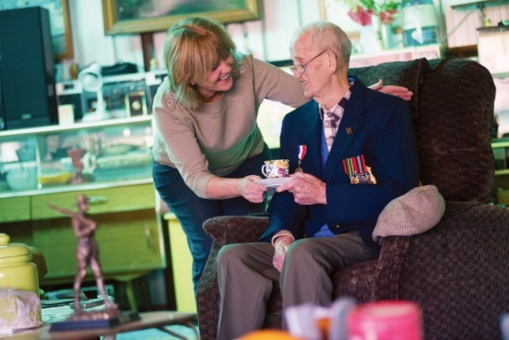

HOW MUCH TIME WILL I NEED TO VOLUNTEER?
We accept that volunteering will be just one activity in your life. We realise that the time and energy you devote to volunteering is at the expense of something else in your life. We know that this is often time spent with your family.

When undergoing training your Mentor will be your guide. He or she will monitor your progress, discuss the pressures you will experience, and help you balance your various commitments.
By the time you are fully trained you will know what is possible for you. Your commitment as an advocate or advocate support officer will always be flexible and reviewable. We will ask only that you keep us informed of your personal situation and availability.

WILL I BE COVERED BY INSURANCE?
Any volunteer or paid practitioner who provides advocacy services to members of the veteran and defence communities and their families must have insurance. While not the exclusive source of this protection, the Veterans’ Indemnity and Training Association (VITA) product is an example of the protection available. VITA fees for volunteers are covered by the ESO that authorises you to provide advocacy services.
VITA was established for the purpose of providing professional indemnity insurance for organisations that provide advice and advocacy services to members of the ex-service community on matters relating to government pensions, benefits and community support services.
VITA also provides an accident insurance policy to cover authorised advocates for accidents that occur at a client meeting, while travelling to and from a client meeting, and for travel to and from training.
More detailed information on VITA can be found at: web.atdp.org.au/docs/vita/VITABrochure2019.pdf
We will discuss our insurance arrangements with you when we talk to you about the advocacy role you would like to undertake.

THANK YOU
If you wish to volunteer we would like to hear from you. If you volunteer we will do everything within our power to ensure success in your chosen role.


